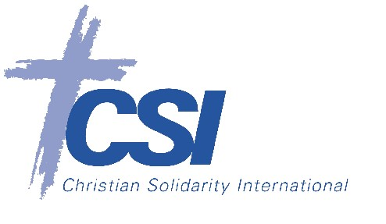

Boston, 5 October 2018

Media release

**Lebanese Christian Scholar: U.S. and Russia Should Cooperate to Protect Pluralism in Middle East**

**Habib Malik Sees Imperial “Callousness” Towards Plight of Minorities**

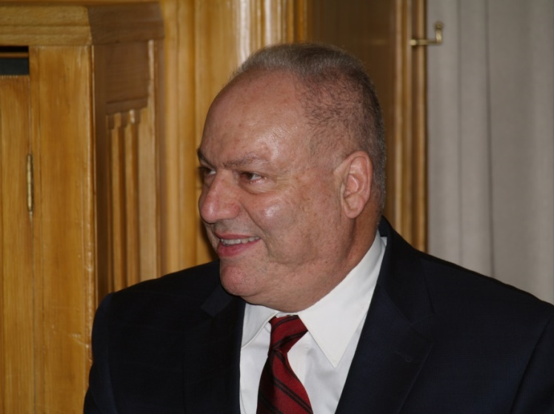BOSTON - When it comes to preserving the Middle East’s endangered religious pluralism, “all possibilities must be explored,” Professor Habib Malik said at a public lecture at Boston College on Thursday. The historian particularly highlighted the benefits that a joint American-Russian effort to “enhance religious freedom” would have for the region’s beleaguered religious minorities and for the fight against Islamic radicalism.

In his lecture, entitled, “Great and Regional Powers in the Modern Middle East: Imperial Actors and their Impact on Socio-Religious Pluralism,” Professor Malik explored in rich detail the history of outside intervention in the Middle East, and what this history can teach us about the existential threat faced by religious minorities in the Middle East today. The lecture was organized by Christian Solidarity International, and cosponsored by Boston College’s Department of Slavic and Eastern Languages and Literatures, the History department, the program in Islamic Civilization and Societies, and the Boston College School of Theology and Ministry.

Professor Malik pushed back against the belief, widely promoted in Middle Eastern politics and Western academic circles, that Western powers and other imperial actors are “primarily responsible” for the Middle East’s protracted crisis and the suffering of its non-Muslim minorities. Instead, Malik pointed to the much older system of *dhimmitude,* or the “deliberate reduction of non-Muslim communities to subjugated second class status” under Islamic law, which has led to “dehumanization” of non-Muslims throughout Islamic history. If imperial interventions in the Middle East have harmed these non-Muslim minority communities, Malik argued, it is because the intervening powers do not “appreciate the fragility of the situation” for these minorities in a region where they have fought to survive for centuries.

From the late 18th century on, Malik explained, Britain, France and Russia were the primary imperial actors intervening in the Middle East, then under the rule of the Ottoman Empire. Russia at first assigned itself the role of protecting the region’s Orthodox Christians, but abandoned that goal during its communist period. Britain and France, on the other hand, occupied large parts of the Middle East after 1918, imposed arbitrary borders on the region without regard for the shape of its pre-existing communities, and imported their own unitary state system to the region. These unitary states were ill-suited to accommodate the region’s religious diversity, and the unitary model they bequeathed opened the door for a series of ruthless military dictators.

The United States did not improve on this record when it rose to superpower status later in the 20th century. Malik observed a “callous disposition” in Washington’s foreign policy establishment towards the plight of Middle Eastern minorities. He made special mention of the U.S. support for authoritarian and radically intolerant dictatorships in the region, its abandonment of Lebanese Christians to Syrian rule in the 1980s, and the destruction of Iraq’s Christian communities in the chaos following the American invasion in 2003. The latter, Malik noted, enabled the rise of the Islamic State (ISIS), “the most lethal development” for religious pluralism in the Middle East.

Nevertheless, Malik was “hopeful” about the prospects for new American-Russian cooperation to protect religious minorities. Both superpowers, Malik argued, are threatened by the terrorism emanating from the Middle East, and both have expressed concern at high levels for the fate of the region’s religious minorities. A “joint coordinated action aimed at bolstering religious pluralism”, Malik said, would be an “effective strategy” against that radicalism, and could represent a “common ground” in a relationship badly strained by the conflicts in Syria and Ukraine and allegations of Russian cyberattacks on American elections.

Any such effort, Malik argued, must confront the reality that “the vast majority of the non-Muslims indigenous to the region” live under political and social duress. To that end, Malik proposed that federal systems, while not a “panacea” would be better able to preserve the region’s diversity and ensure the freedoms of its communities. “The most central ingredient for a vigorous and diverse pluralism,” Malik concluded, “is freedom.”

A video of the lecture can be found here: https://youtu.be/IyjGSjbI5MQ

**About Habib Malik**Habib Malik is an associate professor of history and cultural studies at the Lebanese American University, Beirut. He is the author of *Islamism and the Future of the Christians of the Middle East*, and the son of Charles Malik, the principle drafter of the Universal Declaration of Human Rights of 1948. In 2012, Habib Malik contributed to CSI's lecture series on ‘The Future of Religious Minorities in the Middle East’. Nineteen of these lectures were published this year as an edited volume of the same name by Rowman and Littlefield. www.middle-east-minorities.com

Christian Solidarity International (CSI) is a Christian human rights organization promoting religious liberty and human dignity. [www.csi-schweiz.ch](http://www.csi-schweiz.ch)

**For more information, please contact**Joel Veldkamp | [joel@csi-usa.org](mailto:joel@csi-usa.org)